Note: This document is “view only”. Please create a copy of this document and save it to your drive.

**SOP- External Joint Venture/Affiliate Partners Onboarding, Setup and Management- Systems Vault**

**PREREQUISITES**

[MASTER: SOP- Managing Joint Venture/Affiliate Partners- Systems Vault](https://docs.google.com/document/u/0/d/1MbyGMJz75snwMwT8j9lDfp5OgdlKWnDvI55dQRdbkEc/edit)

[SOP- Project & Task Management- Systems Vault](https://docs.google.com/document/u/0/d/1c7REsC8MsWBBDmtKR6bpULsGVNPt-JGtC7Xwjx9xThg/edit)

[Master: Joint Venture/Affiliate Partners- Systems Vault](https://docs.google.com/spreadsheets/d/1yEJJKKJvoPbetZEajKTPc7TxggX011ywZla51H0CUs0/edit?usp=sharing)

SN JVs & AFFILIATES

SN JV & Affiliate Partners

SN Master: Headshots

[Template: External JV/Affiliate Prep Sheet- Systems Vault](https://docs.google.com/document/u/0/d/19SBzcE8Dzpw837gry3p3ojppexVEiVT6EHp3CR0PY3o/edit)

Folder: Sarah Noked Affiliate/Joint Venture/Speaking Shiz

Access to Sarah’s Google Calendar

[Sarah Noked One Sheet](http://www.sarahnoked.com/sheet)

**PURPOSE**

To ensure that our EXTERNAL **Joint Ventures** (outsiders products, promotions and events we are promoting) are onboarded and set up effectively as well as management ongoing.

**POLICY**

The SN Team is notified of external JV partnerships via [partners@sarahnoked.com](mailto:partners@sarahnoked.com). Under the [JVs & Affiliates](https://sarahnoked.teamwork.com/#/projects/490225/tasks) project in Teamwork, Sarah or the Operations Manager will set up the [[Summit/Mastermind/Podcast Name] with [Host] - [MM/DD/YYYY]](https://sarahnoked.teamwork.com/#/task-templates/2273416) task list for External Partner onboarding in Teamwork PM once a podcast has been confirmed.

There are 4 types of EXTERNAL Joint Venture partners:

1. Podcasts
2. Summits
3. Masterminds
4. Products

**PARTY**

Online Business Manager

**PROPERTY**

Online Business Manager

**PROCESS**

**Part 1: Create and Implement EXTERNAL JV Affiliate Task List in Teamwork for Podcasts, Summit or Products**

Part 1a: Create and Implement JV Affiliate Task List in Teamwork for Podcasts

Part 1b: Create and Implement JV Affiliate Task List in Teamwork for Summits

Part 1c: Create and Implement JV Affiliate Task List in Teamwork for Products

**Part 2: Creating assets for EXTERNAL JVs**

Part 2a: Setting up specific promotion landing page with the JV

Part 2b: Setting up a prep sheet (for Sarah) with [Template: External JV/Affiliate Prep Sheet- Systems Vault](https://docs.google.com/document/u/0/d/19SBzcE8Dzpw837gry3p3ojppexVEiVT6EHp3CR0PY3o/edit)

Part 2c: Creating thumbnails and social media promos.

**PROCEDURES**

**Part 1: Create and Implement EXTERNAL JV Affiliate Task List in Teamwork**

**Part 1a: Create and Implement JV Affiliate Task List in Teamwork for Podcasts**

1. Create a task list for the JV Affiliate. ([SOP- Project & Task Management- Systems Vault](https://docs.google.com/document/u/0/d/1c7REsC8MsWBBDmtKR6bpULsGVNPt-JGtC7Xwjx9xThg/edit)) The name of the task template is “SN Podcast Tasklist [Podcast Name XXX and Host XXX] [Date of Podcast Recording: XXX ] [Date of Podcast Publication: XXX ]”
2. All task assigned to “JV Affiliates Manager/JV Affiliates Support must be assigned accordingly, with due dates and task list names updated

**Part 1b: Create and Implement JV Affiliate Task List in Teamwork for Summits**

1. Create a task list for the JV Affiliate. ([SOP- Project & Task Management- Systems Vault](https://docs.google.com/document/u/0/d/1c7REsC8MsWBBDmtKR6bpULsGVNPt-JGtC7Xwjx9xThg/edit)) The name of the task template is “SN Summit Tasklist [Podcast Name XXX and Host XXX] [Date of Summit Recording: XXX ] [Date of Summit Publication: XXX ] ”
2. All task assigned to “JV Affiliates Manager/JV Affiliates Support must be assigned accordingly, with due dates and task list names updated

**Part 1c: Create and Implement JV Affiliate Task List in Teamwork for Products**

1. Create a task list for the JV Affiliate. ([SOP- Project & Task Management- Systems Vault](https://docs.google.com/document/u/0/d/1c7REsC8MsWBBDmtKR6bpULsGVNPt-JGtC7Xwjx9xThg/edit)) The name of the task template is “SN External Product Tasklist [Product Name XXX and Creator XXX] [Date of Product Promotion: XXX ]”
2. All task assigned to “JV Affiliates Manager/JV Affiliates Support must be assigned accordingly, with due dates and task list names updated

**Part 2: Creating assets for EXTERNAL JVs**

**Part 2a: Setting up specific promotion landing page for promotional purposes**

1. Login to the Sarahnoked.com WP dashboard at <https://www.sarahnoked.com/wp-login.php> using information stored in LastPass
2. Go to Pages>all pages> Search “amazing”> Mouse over ‘Welcome Amazing Listeners’> Duplicate page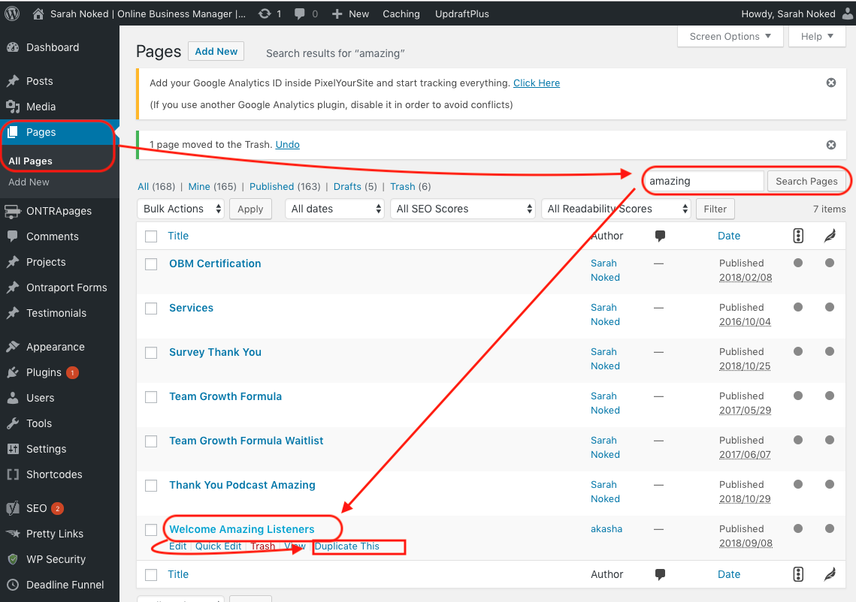
3. Re-search for amazing and find the one that ends in -draft> mouseover and click ‘edit’
4. Update the page as needed
   1. Page Title
   2. Slug
   3. Open the three lines to of the middle ‘text’ section to edit the page 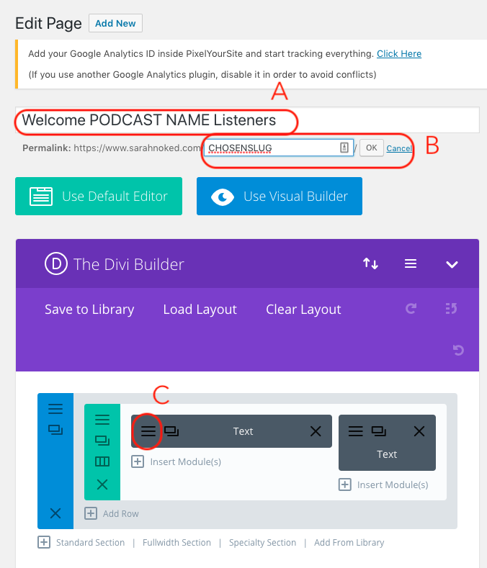
   4. Edit under ‘visual’ tab
   5. Change podcast image
   6. Edit text in three places in the first paragraph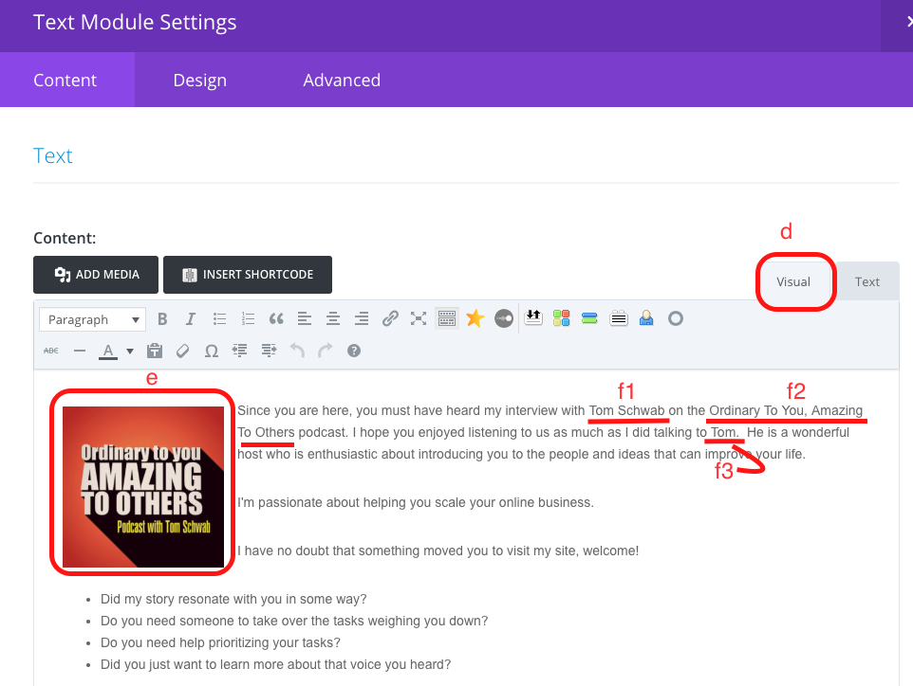
5. On the top right, click ‘publish’
6. Go to the URL, make sure it works, proofread.
7. Add to the appropriate prep sheet.
   1. Create a prep sheet using [Template: External JV/Affiliate Prep Sheet- Systems Vault](https://docs.google.com/document/u/0/d/19SBzcE8Dzpw837gry3p3ojppexVEiVT6EHp3CR0PY3o/edit)
      1. Make sure to add all the necessary information within the sheet. (e.g Interview Date, Promo URL, and Zoom/Skype Link).
      2. Look for the information in the emails from the host.
      3. Specify if the interview is either an audio+video interview or just audio.
      4. If you don’t currently have information for the other details, contact the podcast host at least a week before the interview date.

**Created by:**

**Department:** Marketing

**Date:**

**Revised:**

**Revised by:**